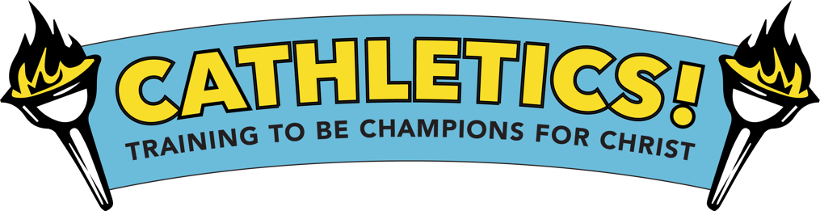
TEEN VOLUNTEER FORM

St. Thecla Catholic Church is planning a
Vacation Bible School program
this summer!

Join the VBS Team!

If you are interested in helping our kids learn their Catholic faith in a fun and exciting way, please return the completed form to Rupkuss@stthecla.com by 6/1/24

The theme is Cathletics: Training to be Champions for Christ

----------------------------------------------------------------------------------------------------------------------------------

❑ Yes! I want to volunteer to help with 2024 VBS

Name (Teen): ______________________________ Teen Cell:______________________________

Address: __________________________________ Teen Birthdate:__________________________

Teen Email:_____________________________

Parent Name:________________________________________ Parent Cell:_______________________________________

Parent Email:_________________________________________

2nd Emergency Contact & phone:____________________________________________________________________________

